APPENDIX A - ISA

INCLUDED
An Instruction Set Architecture (ISA) defines how a processor stores data, interacts with memory, and performs calculations. Implicit Operand: Automatically assumed by the CPU (e.g., MUL AL). Explicit Operand: Directly specified in the instruction (e.g., ADD AX, BX).

- In a stack-based architecture, implicit operands are stored in a stack, with operations using the top values, shrinking or growing the stack accordingly. It is simple and requires fewer instructions but is slow due to frequent push/pop operations. A C = A + B operation involves pushing A and B onto the stack, performing the addition, and storing the result in memory.
- An accumulator-based architecture uses a single special register, the accumulator, which stores intermediate results and is modified with each operation. It is simpler than stack-based architectures and reduces memory access but is inefficient for complex operations since the accumulator is constantly overwritten. For C = A + B, A is loaded into the accumulator, B is added, and the result is stored in memory. One of the operands is implicit. Extended Accumulator Architecture: Special-purpose registers with restricted use.
- General-Purpose Register (GPR) Architecture: (all explicit operands):
  - A register-memory architecture uses general-purpose registers while allowing direct memory access in calculations, making it more efficient than accumulator-based systems but still reliant on memory. In C = A + B, A is loaded from memory into a register, B is added directly from memory, and the result is stored.
  - A register-register (load-store) architecture performs all operations using registers, with memory access restricted to explicit load/store instructions. This approach is the fastest and most common today, as registers are significantly faster than memory. In C = A + B, A and B are first loaded into registers, the addition is performed, and the result is stored back in memory.
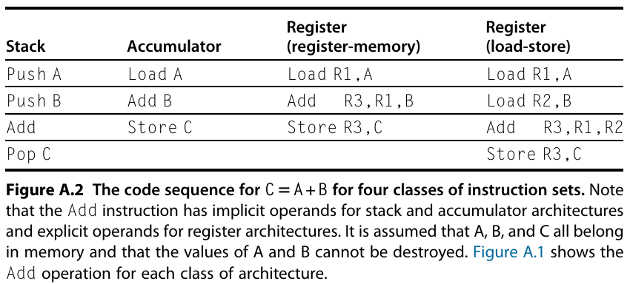
  - Memory-Memory Architecture (obsolete): Keeps all operands in memory.

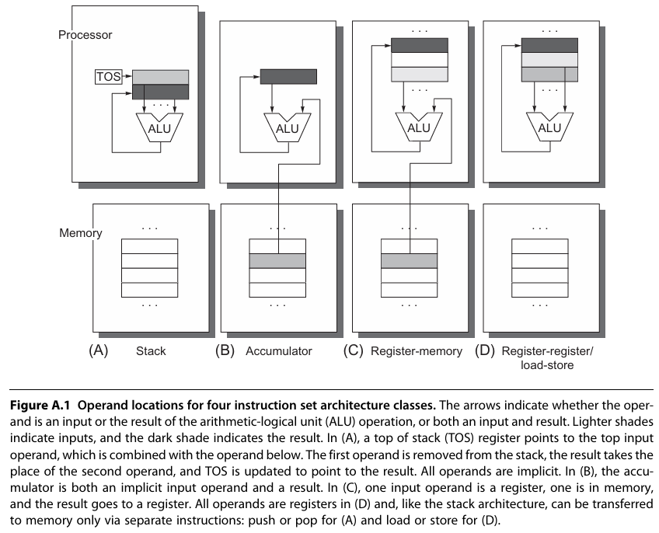
- The explicit operands may be accessed directly from memory or may need to be first loaded into temporary storage, depending on the class of architecture and choice of specific instruction.
- As the figures show, there are really two classes of register computers. One class can access memory as part of any instruction, called register-memory architecture, and the other can access memory only with load and store instructions, called load-store architecture. 3rd obsolete
- Reasons for general-purpose registers (GPR): faster than memory, more efficient for compilers, reduces memory traffic, and improves program speed and code density. Compiler preferences: all registers should be general-purpose; larger register counts improve efficiency.
- The number of registers needed depends on compiler effectiveness, with modern compilers using more registers for expression evaluation, parameter passing, and variable storage, leading to higher register counts in recent architectures.
- ISA Trade-offs: impact on instruction encoding, number of instructions, and implementation strategies.
- GPR architectures differ by two key traits: whether ALU instructions use 2 operands (one acts as both source and destination) or 3 (separate source/destination), and how many operands can access memory (0 for load-store, 1 for register-memory, or 2+ for memory-memory)
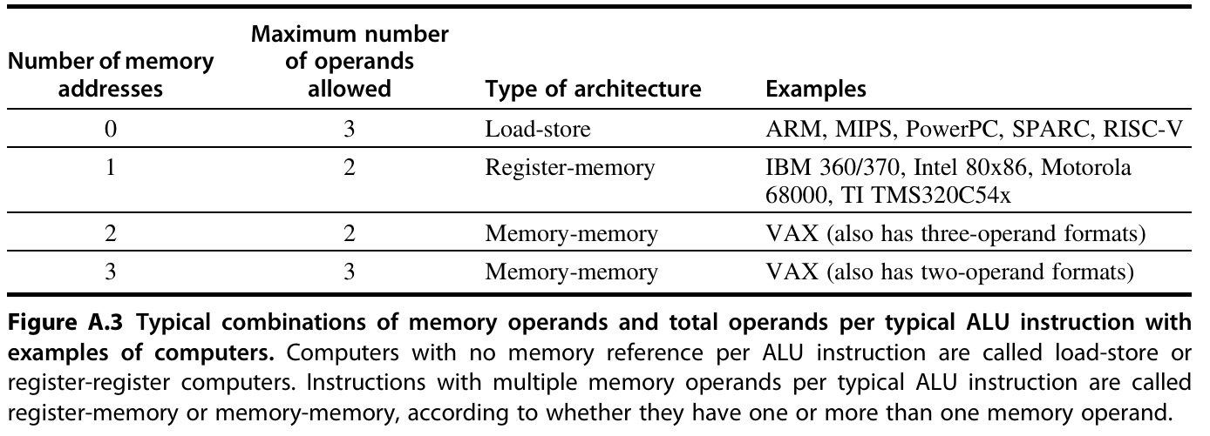
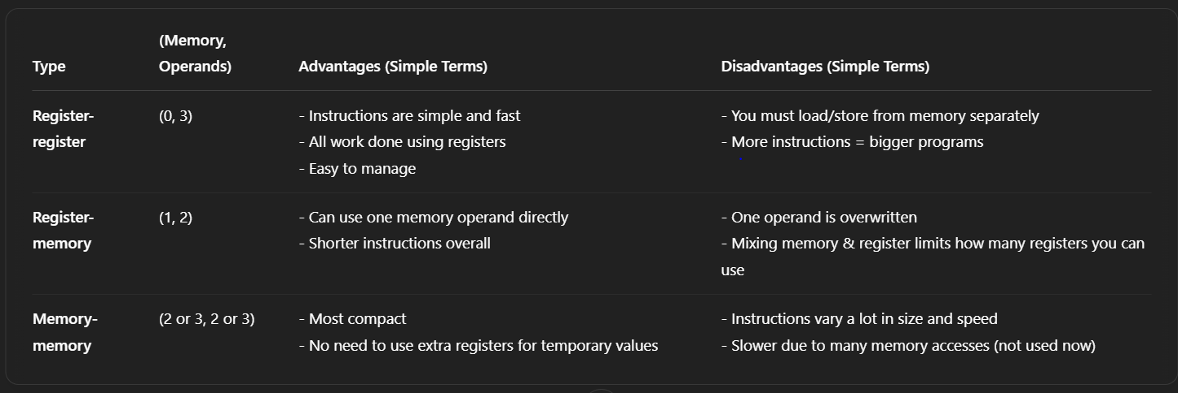

INCLUDED
Memory Addressing: Determines how memory addresses are interpreted and specified, impacting performance and compiler efficiency.
Address Interpretation:
- Byte-addressed systems access bytes (8-bit), half-words (16-bit), words (32-bit), and double words (64-bit).
- Byte Order:
Little Endian: Least-significant byte stored at lowest address.
Big Endian: Most-significant byte stored at lowest address
Memory Alignment: refers to arranging data in memory at addresses that are multiples of their size, improving access speed and efficiency.
- Aligned access: Address A mod s = 0 for object size s.
- Misaligned access: Requires multiple memory references, reducing efficiency.
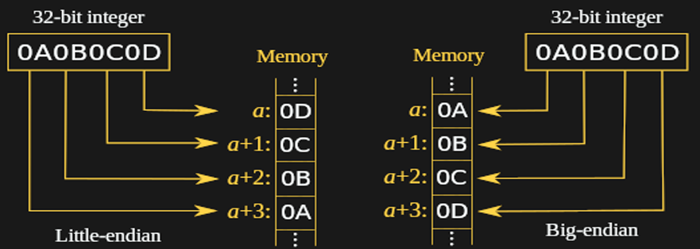
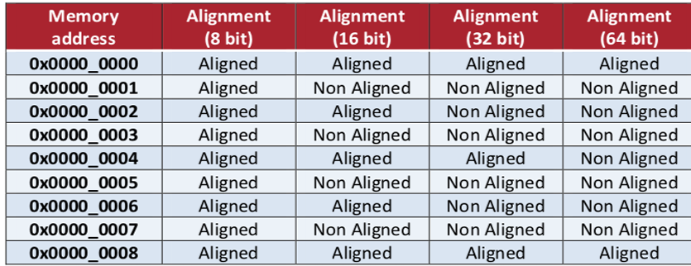
- Example: 4-byte word access aligned at 0, 4, 8…, misaligned at 1, 2, 3….

Addressing Modes: define how an instruction specifies the actual effective address from the memory location/address of an operand using constants, registers, or memory locations.
Addressing Mode | Example Instruction | Meaning | When Used | Description
Direct (Absolute) | Add R1, (1001) | Regs[R1] ← Regs[R1] + Mem[1001] | Accessing static data | Uses a fixed memory address specified in the instruction to retrieve data. Simple, lacks flexibility. Reduces computation time
Register & Memory Indirect | Add R4, (R1), Add R1, @(R3) | Regs[R4] ← Regs[R4] + Mem[Regs[R1]],  Regs[R1] ← Regs[R1] + Mem[ Mem[Regs[R3]] ] (double ptr) | Accessing using a pointer, computed address, or extra level of indirection | The memory address is stored in a register, which is dereferenced to get the value. Used to implement pointers, parameter passing, and linked data structures but may require multiple memory accesses.
Indexed (Base + Offset) | Add R3, (R1 + R2) | Regs[R3] ← Regs[R3] + Mem[Regs[R1] + Regs[R2]] | Useful in array addressing  R2 can change during execution, then added to base | Uses a base register and an index register to dynamically calculate the memory address, useful for iterating through arrays.
Displacement | Add R4, (100 + R1) | Regs[R4] ← Regs[R4] + Mem[100 + Regs[R1]] | Accessing local variables  Fixed value added to base | Combines a base register with a fixed offset to locate data in memory. Commonly used for accessing local variables. Used for relocating a program, where the effective address (EA) is the sum of the base value and displacement.
Immediate | Add R4, 3 | Regs[R4] ← Regs[R4] + 3 | For constants | Uses a fixed constant value directly in the instruction, avoiding memory access. Useful for adding small known values.
Register | Add R4, R3 | Regs[R4] ← Regs[R4] + Regs[R3] | When a value is in a register | The operands are stored in registers, making it the fastest mode as it does not access memory.
Autoincrement | Add R1, (R2)+ | Regs[R1] ← Regs[R1] + Mem[Regs[R2]], then Regs[R2] ← Regs[R2] + d | Stepping through arrays in loops | Automatically increments the register after accessing memory, making it efficient for sequential data traversal like iterating through arrays.
Autodecrement | Add R1, -(R2) | Regs[R2] ← Regs[R2] - d, then Regs[R1] ← Regs[R1] + Mem[Regs[R2]] | Similar to autoincrement, also for stack operations | Automatically decrements the register before accessing memory, commonly used in stack operations (push/pop) and reverse iteration.
Scaled | Add R1, 100(R2)[R3] | Regs[R1] ← Regs[R1] + Mem[100 + Regs[R2] + Regs[R3] * d] | Used in indexed array addressing | Similar to indexed addressing but includes a scaling factor (d), useful for accessing structured data like multi-dimensional arrays.

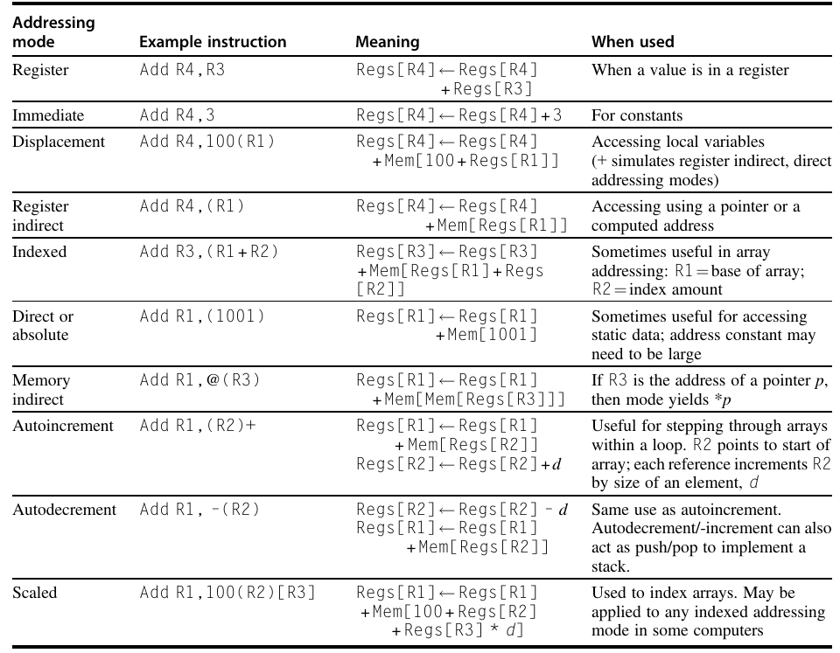

Addressing modes can significantly reduce instruction counts; they also add to the complexity of building a computer and may increase the average clock cycles per instruction (CPI) of computers that implement those modes. The compiler also determines how addressing modes are used and optimizes their selection to improve performance. Thus, the usage of various addressing modes is quite important in helping the architect choose what to include.

INCLUDED

RISC-V Architecture
- RISC-V is a computer instruction set, which means it defines the basic commands a processor can understand and execute.
- A simple load-store instruction set designed for pipelining efficiency, with a fixed instruction set encoding, ensuring efficiency as a compiler target.
- RISC-V has three base instruction sets (32-bit (RV32I), 64-bit (RV64I), and a future 128-bit (RV128I) version) supporting 32-bit or 64-bit integers, with optional extensions for various functionalities like floating-point and vector operations. This flexibility allows RISC-V to be used in a wide range of applications, from low-cost embedded processors to high-end configurations.
- Processors can be simple (cheap and small) or complex (powerful and expensive) depending on which parts of the RISC-V set they use.

Basics of the RISC-V Instruction Set
RISC-V follows a load-store architecture, simplifying pipeline implementation with:
- Operations acting on registers only.
- Memory accessed only via load/store instructions.
- Fixed instruction formats for easy decoding.

Registers in RISC-V
- RV64G (64-bit version) has 32 general-purpose registers (GPRs), named x0 to x31.
- Some versions also include 32 floating-point registers (FPRs) for handling decimal numbers. (can be 32-bit (single precision) or 64-bit (double precision).)
- A full-featured RISC-V processor might be RV64G, which includes the M, A, F, and D extensions.
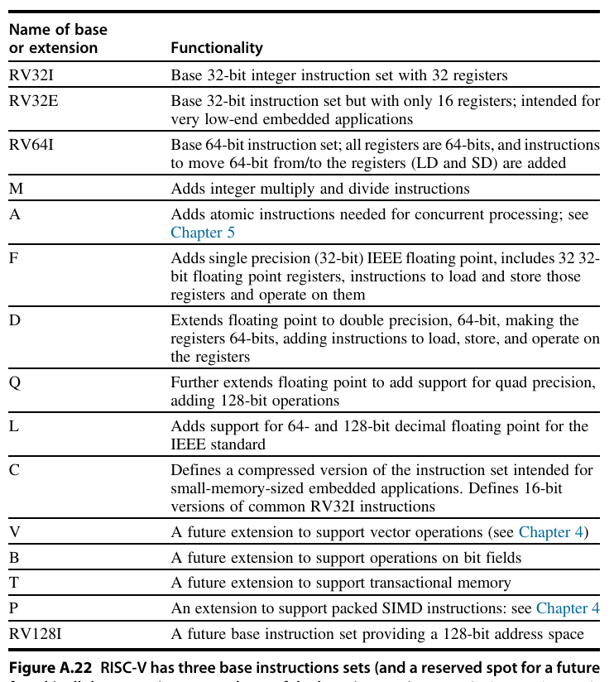
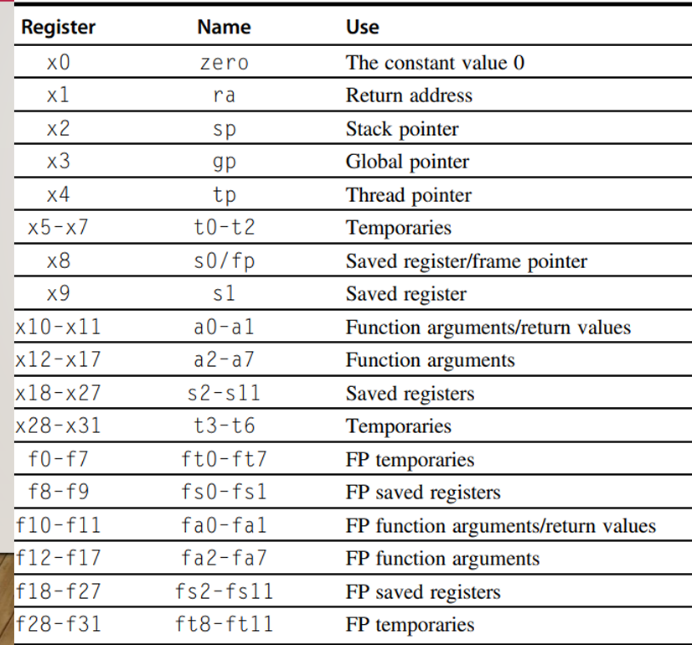

Data Types in RISC-V
- Supports 8-bit (bytes), 16-bit (half-words), 32-bit (words), and 64-bit (double words).
- Floating-point numbers can be 32-bit (single precision) or 64-bit (double precision).

Memory and Addressing
- The architecture supports two data addressing modes: immediate and displacement, with 12-bit fields. Register indirect is accomplished simply by placing 0 in the 12-bit displacement field, and limited absolute addressing with a 12-bit field is accomplished by using register 0 as the base register.
- RV64G is a byte-addressable, 64-bit Little Endian memory system, using load-store architecture for memory access.
- Memory accesses can involve GPRs and FPRs, with support for various data types, though unaligned accesses are discouraged due to potential slow performance.

Instruction Formats
- Instructions are 32-bits long with 7-bit primary opcode and categorized into:
  - R-type – (Register-Register Instructions): Used for arithmetic operations (like addition and multiplication) that involve two registers as inputs and store the result in another register.
  - I-type – (Immediate & Load Instructions): Used for operations that involve a register and an immediate (a fixed number), such as loading a value from memory or performing an arithmetic operation with a constant.
  - S-type – (Store Instructions): Used for storing data from a register into memory.
  - U-type – (Jump & Link Instructions): Used for jumping to a different part of a program (useful for function calls).
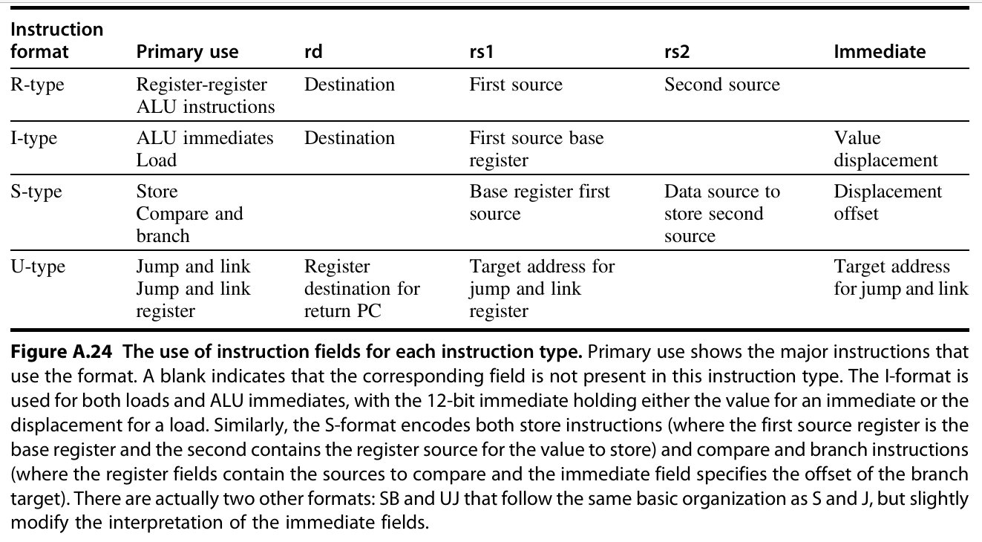
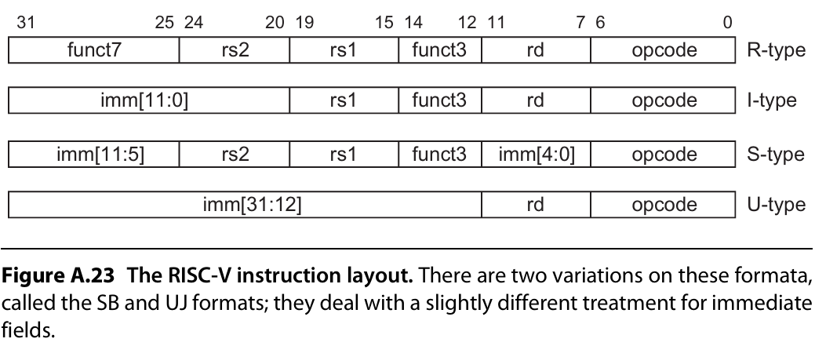

Operations in RISC-V
  - RISC-V supports four broad classes of instructions: loads and stores, ALU operations, branches and jumps, and floating-point operations.
  - Memory operations include 8, 16, 32, and 64-bit loads and stores for integer and floating-point registers, with specific instructions for signed and unsigned operations.
  - Arithmetic and logical operations in RISC-V include simple add, subtract, AND, OR, shifts, and more, with both register-register and register-immediate formats.
  - Control flow is managed through conditional branches and jumps, with support for both PC-relative and register-relative addressing modes.
  - Floating-point operations follow the IEEE 754 format, supporting single and double precision with various arithmetic, comparison, and conversion instructions between integer and floating-point registers.

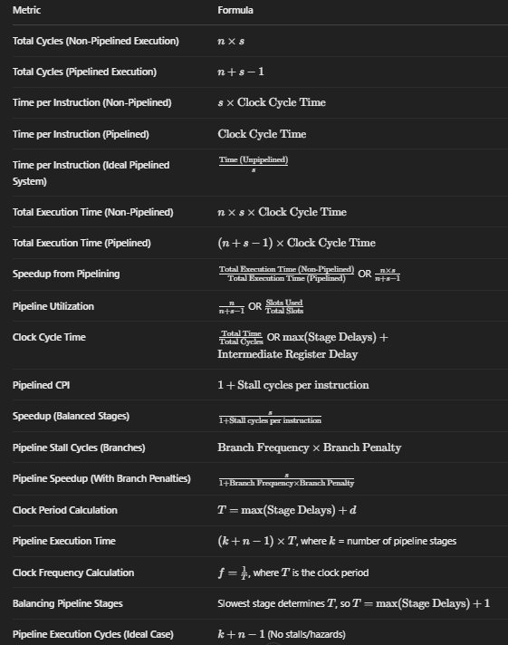
SEE PIPELINING BOOK PDF

Comprehensive Pipeline Performance Formula Table (with CPI)

Metric | Formula
Total Cycles (Non-Pipelined) | n × k
Total Cycles (Pipelined) | n + k – 1
Time per Instruction (Non-Pipelined) | k × Clock Cycle Time
Time per Instruction (Pipelined) | Clock Cycle Time (ideal)
Time per Instr. (Ideal Pipelined) | Time (Unpipelined) / s
Total Exec Time (Non-Pipelined) | n × k × Clock Cycle Time
Total Exec Time (Pipelined) | (n + k – 1) × Clock Cycle Time
Speedup from Pipelining | Unpipelined Time / Pipelined Time OR (n × k) / (n + k – 1)
Pipeline Utilization | n / (n + k – 1) OR Slots Used / Total Slots
Clock Cycle Time | max(Stage Delays) + Intermediate Register Delay
Pipelined CPI | 1 + Stall cycles per instruction
Speedup (with stalls) | CPI_unpipelined / (1 + Stall cycles per instruction)
Speedup (ideal) | Pipeline depth / (1 + Stall cycles per instruction)
Speedup (Balanced Stages) | 1 / (1 + Stall cycles per instruction)
Pipeline Stall Cycles (Branches) | Branch Frequency × Branch Penalty
Pipeline Speedup (Branch Penalties) | k / (1 + Branch Frequency × Branch Penalty)
Clock Period Calculation | T = max(Stage Delays) + d
Pipeline Execution Time | (k + n – 1) × T
Clock Frequency Calculation | f = 1 / T
Balancing Pipeline Stages | T = max(Stage Delays) + 1 (to balance stages if unbalanced)
Pipeline Execution Cycles (Ideal) | k + n – 1 (no stalls/hazards)
Avg Time (Unpipelined) | CPI_unpipelined × Clock_cycle_unpipelined
Avg Time (Pipelined) | CPI_pipelined × Clock_cycle_pipelined
Initiation Interval | Time between starting two consecutive instructions (usually 1 in ideal pipeline)
Latency | Time from instruction entry to completion ( = k × Clock Cycle)
Non-pipelined Instruction (e.g., div) | High latency and high initiation interval

EXAMPLE QS:
Solution: Time Consumed in Processing 10,000 Instructions Using Pipeline

Given Data:
- Number of pipeline stages s = 5
- Stage delays (in nanoseconds):
  - Stage 1: 300 ns
  - Stage 2: 240 ns
  - Stage 3: 320 ns
  - Stage 4: 280 ns
  - Stage 5: 220 ns
- Intermediate register delay = 9 ns
- Number of instructions n = 10,000

Step 1: Determine Clock Cycle Time
The clock cycle time in a pipelined system is determined by the longest stage delay + intermediate register delay:
Clock Cycle Time = max⁡(Stage Delays) + Intermediate Register Delay
Clock Cycle Time = max⁡(300,240,320,280,220) + 9 = 320 + 9 = 329 ns

Step 2: Determine Total Execution Time in Pipeline
Total execution time for a pipeline is given by:
Total Execution Time = (n + s − 1) × Clock Cycle Time
Total Execution Time = (10,000 + 5 − 1) × 329 = 10,004 × 329 = 3,294,316 ns

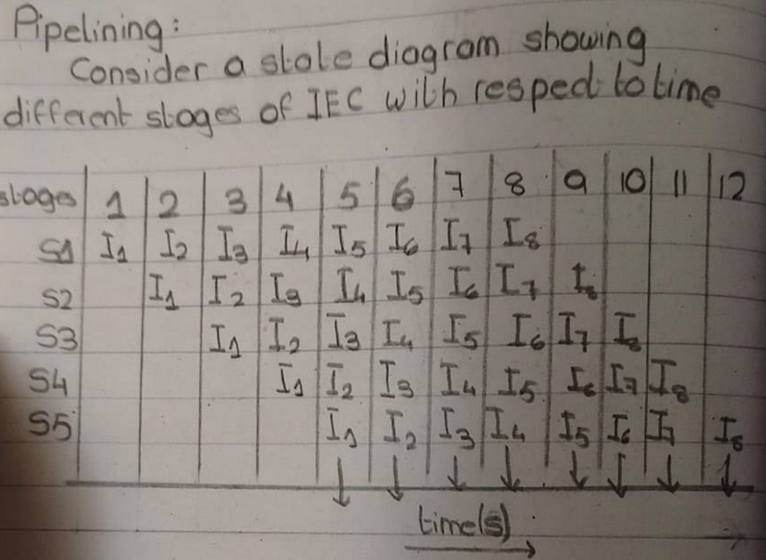

- Without Pipelining:
  - Each instruction takes 5 cycles (one per stage).
  - 8 instructions take: 8×5 = 40 cycles
- With Pipelining:
  - The first instruction takes 5 cycles.
  - Each subsequent instruction enters the pipeline one cycle after the previous one.
  - Total cycles needed for 8 instructions in a 5-stage pipeline: 8 + 5 - 1 = 12 cycles
- Speedup Calculation:
  - Speedup is the ratio of execution time without pipelining to execution time with pipelining: 40/12 ≈ 3.33
  - This means pipelining makes execution approximately 3.33 times faster.
- Pipeline Utilization:
  - Formula: Slots Used/Total Slots = 40/60 = 66%
  - The utilization of the pipeline is 66%, meaning some pipeline slots remain unused due to stalls or dependencies.

Pipeline Hazards Overview
Pipeline hazards are issues that arise in pipelined CPU architecture and can be classified into:
- Data Hazards – Occur when instructions depend on the results of previous instructions.
- Control Hazards – Occur due to branch instructions affecting instruction flow.
- Structural Hazards – Happen when hardware resources are insufficient.

Example 1: Data Hazard (RAW - Read After Write)
Given Instructions:
I₁ → IF/D OF EX Mem WB
I₂ → IF/D OF EX Mem WB

I₁: R₃ ← R₃ + R₄ (Write to R₃)
I₂: R₆ ← R₃ + R₅ (Read from R₃)

Issue:
- Instruction I₂ reads R₃ before I₁ writes its updated value.
- This results in an incorrect computation.

Solution (Forwarding or Stalling):
- Forwarding: The output from I₁ (ALU result) can be directly fed into I₂ as an input.
- Stalling: Introduce a delay (pipeline bubble) so that I₂ waits until I₁ completes.

Example 2: Control Hazard (Branch Instruction)
Pipeline Stages for Multiple Instructions:
I₁: IF -> ID -> OF -> EX -> MEM -> WB
I₂: IF -> ID -> OF -> EX -> MEM -> WB
I₃: IF -> ID -> OF -> EX -> MEM -> WB
I₄: IF -> ID -> OF -> EX -> MEM -> WB

Issue:
- If I₁ is a conditional branch, the next instruction fetch (I₂, I₃, etc.) might be wrong.
- If the branch is taken, the pipeline must flush incorrect instructions.

Solution:
- Branch Prediction: Predict whether the branch is taken and execute accordingly.
- Pipeline Flushing: If the prediction is wrong, flush the pipeline and restart execution.

Example 3: Structural Hazard
Occurs when two instructions require the same hardware resource (e.g., memory access).

Solution:
- Use separate instruction and data memory (Harvard Architecture).
- Introduce pipeline registers to avoid resource conflicts.

Remedies for Pipeline Hazards
- RAW (Read After Write) → Forwarding/Circuit Switching.
- WAR (Write After Read) & WAW (Write After Write) → Register Renaming.
- Stalls (if needed) to allow dependencies to resolve.

Problem 1: Clock Time Period Calculation
Given:
- 5-stage pipeline with stage delays: 1, 2, 3, 1, 1 units
- Latch delay d = 0
Formula:
T=max⁡(stage delays)+d
Solution:
T=max⁡(1,2,3,1,1)+0=3 units
Answer: The clock time period is 3 units.

Problem 2: Pipeline Execution Time for Two Processors

Given:
- Processor P₁: 5-stage pipeline with stage delays 3, 2, 4, 2, 3 ms
- Processor P₂: 8-stage pipeline with each stage taking 2 ms
- n = 100 items processed

Formula for Execution Time:
Time=(k+n−1)×T
where:
- k = number of stages
- T = clock period (max stage delay for P₁, fixed for P₂)

For Processor P₁:
T=max⁡(3,2,4,2,3)=4 ms
(5+100−1)×4=104×4=416

For Processor P₂:
T=2 ms(fixed)T = 2 ms
(8+100−1)×2=107×2=214 ms
Answer:
- P₁ Execution Time: 416 ms
- P₂ Execution Time: 214 ms

Problem 3: Balanced Pipeline Clock Frequency

Given:
- 5-stage pipeline with delays: 10, 12, 13, 12, 14 ns
- Latch delay = 1 ns

Step 1: Compute Clock Period
T=max⁡(10,12,13,12,14)+1=15 ns

Step 2: Compute Clock Frequency
f=1/T=115×10^−9=66.67

Step 3: Balancing Pipeline
To balance, the slowest stage determines T. Since 14 ns is the bottleneck,
T=14+1=15 ns (same as original)
No further balancing is possible without modifying stage delays.
Answer:
Clock frequency = 66.67 MHz
Clock period = 15 ns

Problem 4: Pipeline Cycles Calculation

Given Instructions:
- R4=R5+R6
- R2=R2+R0
- R3=R2+R0
- R4=R5−R6
- R2=10m[R3+10]
- R3=10m[R2+0]
- R4=R9=R8

Assumptions:
- 5-stage pipeline (IF, ID, EX, MEM, WB)
- No forwarding or hazards (ideal case)

Formula for Pipeline Cycles:
Total Cycles=k+n−1
where:
- k = 5 (pipeline stages)
- n = 7 (instructions)

Solution:
Total Cycles=5+7−1=11 cycles
Answer:
Total cycles consumed = 11 cycles

Key Takeaways:
- Clock Period (T) = Slowest stage delay + latch delay.
- Pipeline Execution Time = (k+n−1)×T(k + n - 1) \times T(k+n−1)×T.
- Balancing Pipeline: Slowest stage determines T; frequency is 1/T1/T1/T.
- Ideal Pipeline Cycles = k+n−1k + n - 1k+n−1 (assuming no stalls or hazards).

Given:
- Clock cycle = 0.5 ns
- ALU (40%) = 4 cycles
- Branch (20%) = 4 cycles
- Memory (40%) = 5 cycles
- Pipelining overhead = 0.1 ns

🔹 Unpipelined Avg Time:
= 0.5 ns × (0.4×4 + 0.2×4 + 0.4×5)
= 0.5 ns × (1.6 + 0.8 + 2.0)
= 0.5 ns × 4.4
= 2.2 ns

🔹 Pipelined Time:
= 0.5 ns + 0.1 ns = 0.6 ns

🔹 Speedup:
= 2.2 ns / 0.6 ns ≈ 3.7×
✅ Pipelining makes it 3.7 times faster.

Given:
- 4 pipeline stages: IF, ID, EX, WB
- All stages take 1 cycle, except:
  - EX:
    - ADD / SUB takes 1 cycle
    - MUL takes 3 cycles
- Operand forwarding is allowed (so we don’t always wait for WB stage)

🧾 Instructions:
I1: ADD x2, x1, x0 → EX = 1 cycle
I2: MUL x4, x3, x2 → EX = 3 cycles
I3: SUB x6, x5, x4 → EX = 1 cycle

🧠 Key Idea:
- Start a new instruction in each clock cycle (standard pipelining).
- But if a later instruction depends on a previous one still in EX, it might stall.
- With forwarding, we avoid some stalls, but can’t read from a register before it’s written.

Execution Chart (as drawn in the image):
Instr | 1 | 2 | 3 | 4 | 5 | 6 | 7 | 8
I1 | IF | ID | EX | WB
I2 |  | IF | ID | EX |  |  | WB
I3 |  |  | IF | ID |  |  | EX | WB

📌 Final Answer:
✅ 8 clock cycles to complete all instructions.

Given:
- 4 phases: 60, 50, 90, 80 ms
- Latch delay = 10 ms
- Number of tasks = 1000
(a) Pipeline cycle time tp:
Max stage time + latch delay = 90 + 10 = 100 ms
(b) Non-pipelined execution time tnp:
Sum of all stages = 60 + 50 + 90 + 80 = 280 ms
(c) Speedup S:
S = tnp / tp = 280 / 100 = 2.8
(d) Pipeline time for 1000 tasks tpipeline:
Formula: (k + n - 1) × tp
= (4 + 1000 - 1) × 100 = 1003 × 100 = 100300 ms
(e) Sequential time for 1000 tasks tseq:
= 1000 × tnp = 1000 × 280 = 280000 ms
(f) Throughput:
= 1000 / 100300 ≈ 0.00997 tasks/ms

Given:
- Instructions:
  - I0: R1 = R1 + R0
  - I1: R2 = R3 - R1 → depends on I0
  - I2: R4 = R5 + R6
  - I3: R2 = Mem[R3 + 100]
  - I4: R2 = Mem[R2 + 0] → depends on I3
  - I5: R2 = R2 & R1 → depends on I4
  - I6: if (R2 == R1) goto B → depends on I5
  - I7: T5 = Mem[R2 + 100] → depends on I6
- Operand forwarding is enabled
- Hazard-handling introduces stalls where needed

Solution Table:
Instr | 1 | 2 | 3 | 4 | 5 | 6 | 7 | 8 | 9 | 10 | 11 | 12 | 13 | 14 | 15 | 16 | 17
I0 | F | D | E | M | WB
I1 |  | F | F | D | E | M | WB
I2 |  |  |  | F | D | E | M | WB
I3 |  |  |  |  | F | D | E | M | WB
I4 |  |  |  |  |  | F | F | F | D | E | M | WB
I5 |  |  |  |  |  |  |  |  | F | F | F | D | E | M | WB
I6 |  |  |  |  |  |  |  |  |  |  |  | F | D | E | M | WB
I7 |  |  |  |  |  |  |  |  |  |  |  |  | F | D | E | M | WB

Answer: Total clock cycles = 17

Given Frequencies:
- Unconditional branch: 4% = 0.04
- Conditional branch (untaken): 6% = 0.06
- Conditional branch (taken): 10% = 0.10

Branch Penalties per Scheme (from Figure C.12 and C.13):
Scheme | Uncond (×0.04) | Untaken (×0.06) | Taken (×0.10) | Total CPI Addition
Stall pipeline | 2×0.04 = 0.08 | 3×0.06 = 0.18 | 3×0.10 = 0.30 | 0.56
Predicted taken | 2×0.04 = 0.08 | 3×0.06 = 0.18 | 2×0.10 = 0.20 | 0.46
Predicted untaken | 2×0.04 = 0.08 | 0×0.06 = 0.00 | 3×0.10 = 0.30 | 0.38
So, if base CPI = 1:
- Stall scheme: Total CPI = 1.56
- Predicted taken: CPI = 1.46
- Predicted untaken: CPI = 1.38
✅ Speedup examples:
- Predicted untaken vs Stall: 1.56 / 1.38 ≈ 1.13×
- Ideal (no stalls) vs Stall: 1.56 / 1.00 = 1.56×

